Ph : 0160-2639256
2639178, 2639719

GREENWAYS SCHOOL
RURKI HEERAN
A Co-educational C.B.S.E. Affiliated Senior Secondary School

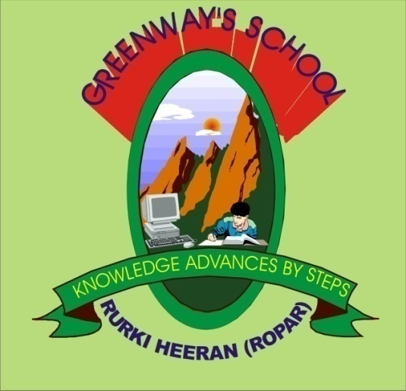

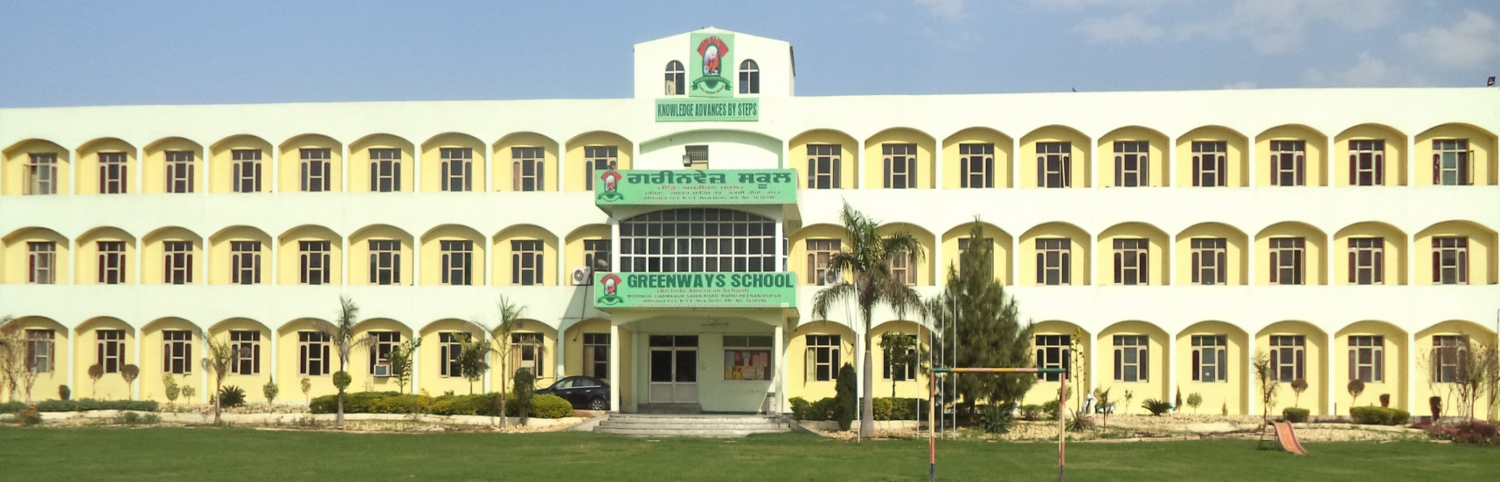
Success is a Journey Not a Destination

P R O S E P E CT U S

PREFACE

Greenways School Rurki Heeran has a distinction of ushering in a new era to serve the humanity through the field of education. Here we are committed to impart quality education with the latest Educational Technology affording the modern facilities. It prides itself for creating a unique, inspirational academic to build in students the character and right attitude by unfurling their aptitude and develop their skills, finally be the refined human beings and be properly educated upholding the eternal values of life.
The school is situated amidst Health Enhancing Salubrious Environment away from the hustle and bustle of the city.

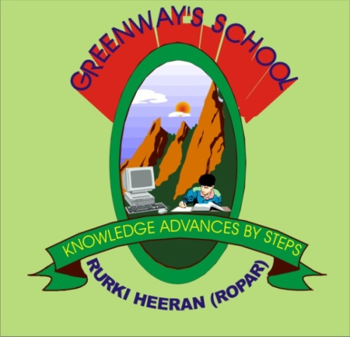

GREENWAYS SCHOOL
RURKI HEERAN
A Co-educational C.B.S.E. Affiliated Senior Secondary School

Dedicated to
the fond memory of
LATE MATA BALBIR KAUR SIDHU

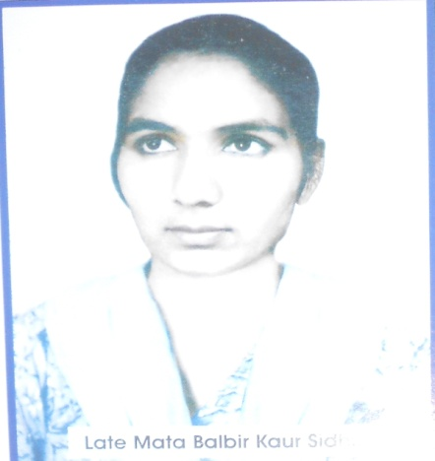
Late Mata Balbir Kaur Sidhu was a religious lady of distinguished qualities and abilities. She was simple and God fearing lady. Her attitude and thoughtfulness paved the way for her son, Mr Sarbjit Singh Sidhu to achieve a glory and recognization in society. He established this institution to enlighten the mankind in general and the nation in particular. Late Mata Balbir Kaur Sidhu was a philanthropist and a social reformer.

Our Emblem Depicting Our Motto

OUR MOTTO

KNOWLEDGE ADVANCES BY STEPS

G - guidance, motivation and inspiration to all students
R - revolution in modern educational systems
E - ensure moral, physical, emotional and psychological growth
E - enthusiasm imbibed to broaden all horizons.
N - nurture the tender buds and make them beautiful flowers of nation
W - willingness to achieve the best
A - acquire knowledge, values, traditions and patriotism
Y - yield positive efforts to attain goals
S - simplicity, honesty, charity and humanity in every student of Greenways.

MESSAGE

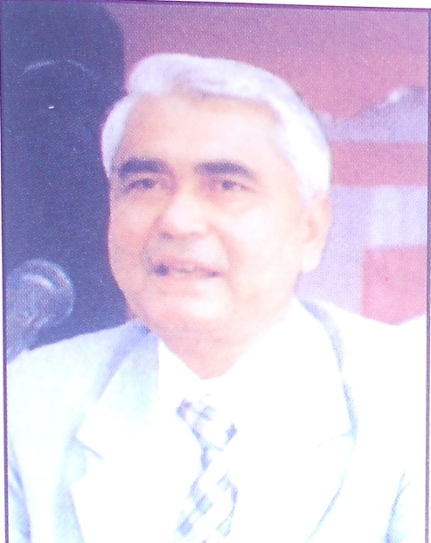
On the solemn occasion of the launching of its second prospectus, I heartily congratulate the management, faculty members and students of Greenways School.
The Sapling of this institute planted few years ago has bloomed up into a fully grown tree in the from of this institute.
My message to the students is that they should believe in themselves and work hard.

Remember Robert Frost’s immortal lines.

“Woods are lovely and deep,
But I have promises to keep,
Miles to go before I sleep”

Mohammad Izhar Alam, Padamshree
A.D.G.P. (Vigilance)

FROM THE MANAGEMENT DESK

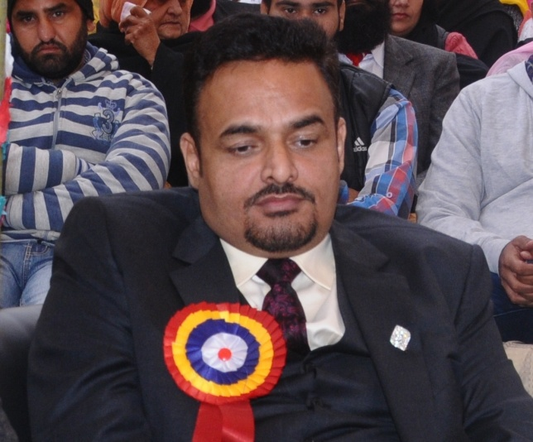
I am highly grateful to the Almighty who has showered his blessings on us with immense faith and service to mankind and strengthened to establish this institution. I express my gratitude to all the parents who have shown faith in us by sending their wards to “GREENWAYS SCHOOL”. I am obliged by the trustees and members of advisory board for their valuable contribution in bringing the school to a matured level despite being in infancy stage.

During the first year of our hard efforts we are trying our best to overcome all teaching problems. Our Principal and our qualified staff members have pledged to devote and play an important role in promotion of goodwill, harmony and mutual understanding with imparting quality education.

We are confident that we will achieve the best, excel in every field and extend our cooperation in making every child of our shine and “BE THE BEST”. I thank the parents once again for their confidence they have reposed in us and assure them the best education for their wards with DEDICATION, INSPIRATION, MOTIVATION AND APPRECIATION to achieve all rewarding goals.

WITH BEST WISHES

Mr. Harjinder Singh Malhi
Managing Director

FROM THE DESK OF THE PRINCIPAL

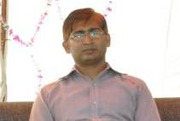
It is indeed a great pleasure to be part of an institution like Greenways School which has created a name for itself by providing quality schooling. We strive to provide balanced education to the pupils as the school believes in holistic development of a child prodigy.

A dynamic and progressive school system is characterized by the extent and magnitude of the care it takes of its pupils and thereby of their future. We leave no stone unturned to meet the manifold needs of the children such as intellectual, emotional, spiritual and disciplinary. The school provides a stimulating environment to let the young ones bloom and develop the quality of character, integrity and social consciousness.

We seek active co-operation involvement from the parents so that our efforts to strive scholastic and co-scholastic excellence may reach fruition. We are fully equipped to meet the challenges, the new generation calls forth. We pledge to continuously endeavors and produce well balanced, capable individuals and leaders to tomorrow who can blaze a new trail and make a qualitative difference to this world.

“Child is the most precious gift, God has ever
Made to man and to educate the child
Is the most noblest cause on this earth.”

Mr. Jitender Saxena
PRINCIPAL

THE SCHOOL CAMPUS AND BUILDING
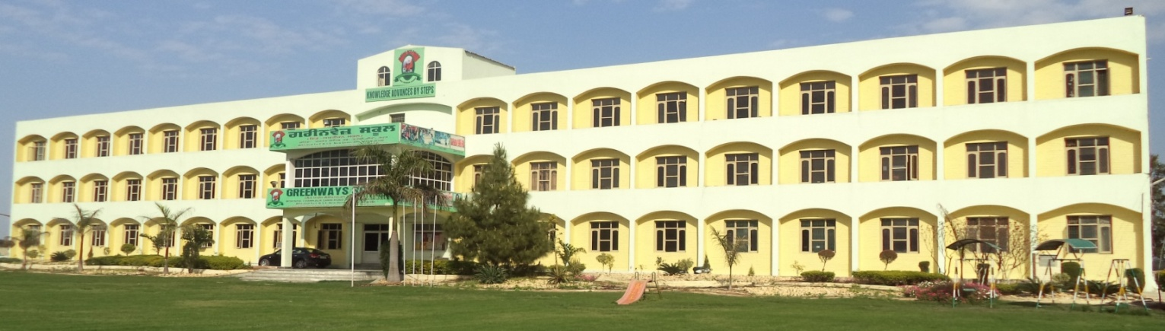
Greenways School opened its doors in the year 2004 with an enrolment of 200 students. Today it is a CBSE Affiliated Senior Secondary, innovative, Co-Educational, English Medium School with over 500 students.

The school is spread over 4 acres of land. It consists of impressive, adequate and well ventilated building, lush green lawns and play field. The classrooms are spacious and equipped with modern facilities, comfortable furniture and teaching aid and modals. The campus provides healthy, neat and clean surroundings for the students. The academics & non academics blocks have full fledged facilities covering every sphere. The swimming pool soon to be constructed would add another feather in the cap.

Aims and Objectives
The aim of the school is to impart quality education blended with Indian Heritage and Discipline with the modern Amenities, which make the student’s Dream come true. The School ensures that all the students reach their fullest individual potential and become self-sufficient, productive, responsible and capable of meeting the demands of a diverse society- All our academic and curricular activities are planned in such a way that it fasters the intellectual, physical and emotional development of the students. The aim of education is all around development of personality of the students to enable them experience the three dimensions of knowledge:
- Moral and Culture
- Scientific and technical
- Economic and Social
We are living in a dynamic society in which the young minds have an opportunity to explore, identify and develop their own personalities.
AN INSTITUTION WITH A MISSION

Greenways School is a contemporary co-educational school where English is the medium of instruction. The course content and curriculum followed are in accordance with CBSE pattern. The school is managed by highly qualified and experienced dignitaries of repute. In several innovative ways necessary impetus is provided extra curricular activities like debates, dramatics and elocution. special music and dance workshops are conducted. Individual attention-oriented teacher-student ratio is maintained. Beside regular medical examination of all students is provided. The school is affiliated to CBSE upto senior secondary level.

We look at education as initiation into creative, socially relevant intellectually satisfying and spiritually elevating life. Greenways School develops and fine-tunes the imagination and refines the heart of the blooming generation and opens for them a window to the world.

WE BELIEVE

Education can be viewed as the transmission of the values and accumulated knowledge of a society. In this sense, it is equivalent to what social scientists term socialization or enculturation. A child… is born without a culture. Education is designed to give him a culture, moulding his behavior in the ways adulthood, and guiding him toward his eventual role in society. To help them acquire an equipoise of physical, mental and moral aspects of personality.

HISTORY OF SRI CHAMKAUR SAHIB

To get the patronage and blessings from the Gurus in the close vicinity of historical, religious and sacred place Sri Chamkar Sahib.
This School is surrounded by five famous historical Sikh Gurudwaras Sri Katalgarh Sahib, Sri Garhi Sahib, Sri Damdama Sahib, Sri Tari Sahib and Sri Ranjitgarh Sahib. In the year 2004 at Sri Chamkaur Sahib lakhs of Sikhs across the globe congregated to pay tributes to the two elder Sahibzadas of Guru Gobind Singh and other Singhs’ on the historical occasion of the 300th anniversary of their martyrdom.

Sri Chamkaur Sahib has a famous historical building named Chamkaur de- garhi also named as Kachhi Garhi. It is this Garhi where Guru Gobind Singh Ji spent two most crucial days December 20th and 21 st in the year 1704 where he with this Sahibzadas fought a war against armies of Mughal’s and Pahari Rajas.

BRIEF HISTORY OF SCHOOL & LOCATION

Greenways School is situated on Morinda Chamkaur Sahin Road(Lutheri). The School is 7 KMS from Morinda and approximately 6 KM from Sri Chamkaur Sahib(Rurki Heeran) being the central point.

It was established on 12th October 2003 with an object to provide an all round development to each and every child admitted at Greenways. The school building is contructed in two phases. The first phase was completed on 10th February 2004 and inaugurated by the eminent personality MR. IZHAAR ALAM, ADGP on 22nd February 2004. Mr Sarabjeet Singh Sidhu Founder Director of the school opened its gate for class Nur-VIIth onwards where one class every year will be upgraded.

GWS offers its students a wealth of learning experiences. No matter what their age, children can benefit from quality teaching delivered in a positive and supportive environment.

The aim of the school is to impart Quality Education blended with Indian Heritage, Cultural Ethos

SCHEME OF EDUCATION

The school is working under the norms of CBSE(New Delhi). It is affiliated with C.B.S.E.(New Delhi) since 2004. The medium of instruction from Nsy to XII class is English. Even the language of the campus is English. It is mandatory for the students to converse in English inside the campus. Hindi and Punjabi are also taught as subjects.

There is a lot of talk and discussion about the reformation on the Examination System Exam. around the world. The CBSE, too has brought and implemented the reformation in the schools affiliated to its Board. Though the school is already following the system, it is to bring to the kind notice of the valued parents that school will follow two formatives exams in one term and there will be two terms altogether. On such case it is understood that there will be four formative assessments and two summative examinations in an academic year. At the end of the academic year, the school will take out the summative value and declare the grades. The details of the Grade will have been shown in the Report Card. The School will adopt this system from the classes Nsy to X.

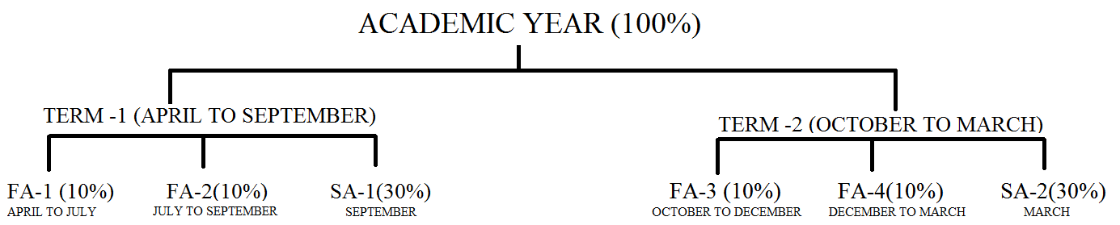

As for as the classes Nsy to UKG are concerned, a flexible examination system will be adopted. They will have three units. The details of the units can be obtained from the students’ almanac. As it is continous Comprehensive Evaluation both the Scholastic and Co-scholastic areas will be well taken care.

SCHOOL ASSEMBLY
The School assembly serves as an important forum for building the moral fabric of the children. The speeches delivered by students give them a platform for expressing their own thoughts and views: the Principal observations and visits of dignitaries and renowned educationists provide the right prespective in the mind of the child. Moreover, under the watchful eye of well-trained House Tutors and teachers, an atmosphere for a value-based education is created for students.

To overcome stage fear each Greenwaysians is trained to perform on the stage. It is compulsory for each and every student to come on the stage and perform.

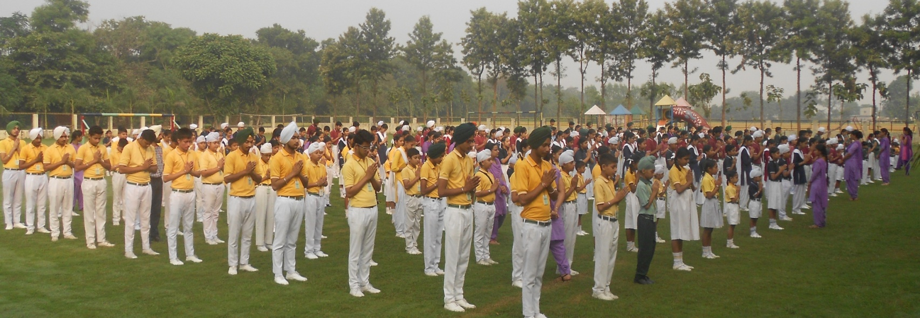

THE FACULTY

The degree of excellence of the institution reveals through its faculty. The school is directed by a competent, capable and creative Principal having more than 10 years experience in academic sphere. The school has a team of qualified experienced C.C.E trained staff to inculcate morals and values in the shape of wholesome education at par excellence. To acquaint with new techniques and methods of education the school provides seminars and teacher workshops to the faculty time to time.

The fruits of the earth do not more obviously require labour and cultivation to prepare them for our use and subsistence than our faculties demand instruction. To provide instructions to the fruits of the society, Greenways has a galaxy of educated faculties who have been selected after going through several tough rounds of judgment. The teachers are well-trained to give the students guidance as a father and caress them with the loving touch of a mother. The school also provides different training programmes and workshops for the teachers to refresh and update their knowledge throughout the year.

HOUSE SYSTEM

Leadership equality is developed and perfect Discipline is maintained through the division of the School into four houses(Beas, Chenab, Ravi and Satluj) in all the fields curricular and co-curricular activities.

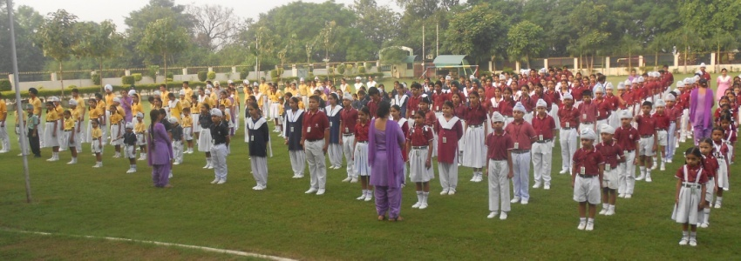
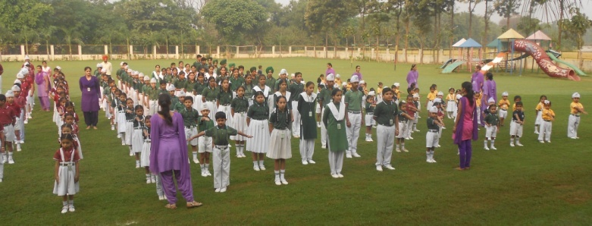

The house system creates a spirit of healthy competition in the sphere of sports and other activities and also to develop the all round personality and to search the hidden and inborn talents of our students. Each house is headed by a House-In-Charge assisted by a few more teachers. House competitions are held time to time to bring holistic development amidst the children. There are House Captains and Vice Captains among the students to assist the House InCharge.

CLASSROOM
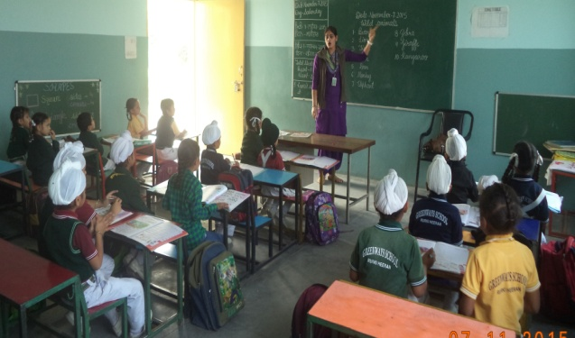
The classrooms are spacious and airy. The seating arrangement in the classrooms is uncluttered to facilitate comfortable interaction between the teacher and the students and allows the teacher and the students enough room for movement. The classrooms are well-lit and the furniture endures comfortable and proper body posture.

COMPUTER LABORATORY

Computer is the buzzword today. The school is fully believed to the power and potential of computers as a field as well as a teaching aid. The school has a computer laboratory equipped with online UPS. The students are exposed to the world of computers from day one. While the students of primary classes learn to draw and design as they work on their computers, senior students design websites, surf the internet and work on educational CDs. Senior students are assigned projects, in groups , to create room for innovation and creativity.

AUDIO-VISUAL CUM LANGUAGE LABORATORY

Application of modern technology in education is needed to cater the taste of modern times. Therefore, it has always been our attempt to apply modern technology in our teaching learning process to increase it effectively. Audio-Visual teaching is a testimony to this endeavor made by Greenways.

PHYSICS, CHEMISTRY, BIOLOGY AND MATHS LAB

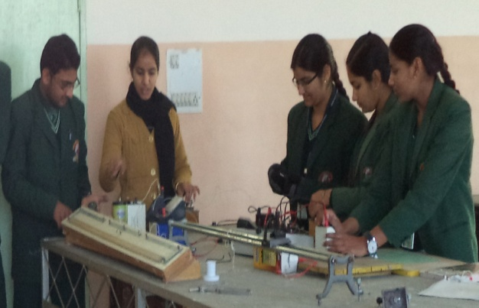
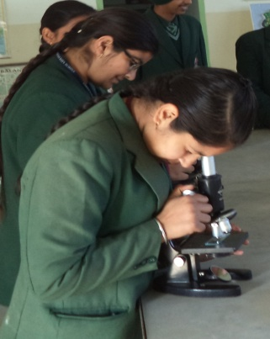
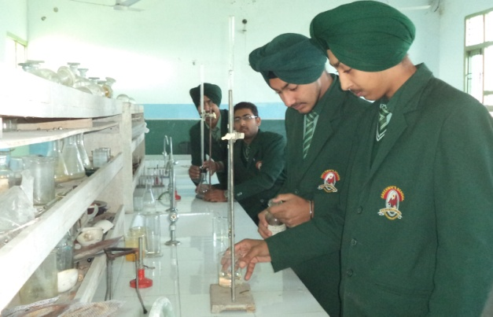
We firmly believe in the demonstrative method rather than the traditional theory based approach for building up a coherent picture where science subjects are concenrned. To fulfill this mission in the rapidly changing educational arena and to keep in touch with the latest technological facets, well designed and fully equipped Science and Maths laboratories have been set up in the school in accordance with the guidelines prescribed by the CBSE. The availability of highly qualified panel of professionals to guide and motivate the students in their pursuit for excellence, is one of the unique attributes of this school.

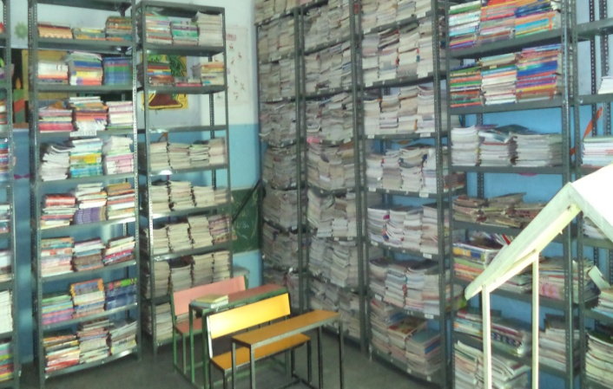
LIBRARY
A rich and dynamic collection of books on various subjects, reference books, Encyclopedias, Dictionaries, Yearbooks, Geographical Resource Book, Audio Visual aids, Non-Book material and periodicals in different fields are available in the school library for ready reference. The OPEN ACCESS System provides encouragement to independent studies for young children, Story Hour, Book Talk, and Quiz Sessions are organized. The interest in reading is developed through pictorial books, Audio Video Cassette, Book Exhibition. Readers Club and Library Weeks help to promote broad reading habits.

SMART CLASS PROGRAMME
Smart Class is a technology oriented initiative for schools. It provides tools and contents for interactive self paced learning by students as well as rich media presentation for teachers—led classroom learning. It is installed on the school’s local server for faster and more reliable access to the content. The content available consists of pedagogically sound and visually rich curriculum resources mapped and customized as per the school’s scheme of work. This content can be streamed into the class rooms and shown by teachers in the classroom to make abstract concepts real.
IT EMPOWERS TEACHING AND INSPIRES LEARNING
This will make learning an enjoyable experience for the students while improving their overall academic performance in the school.

ART AND CRAFT
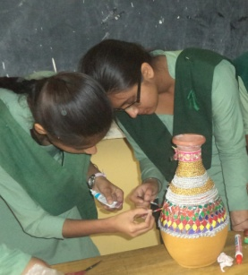
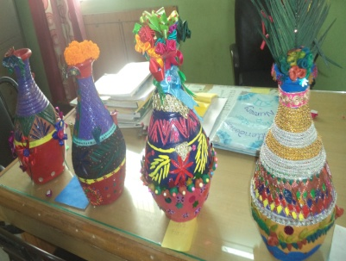
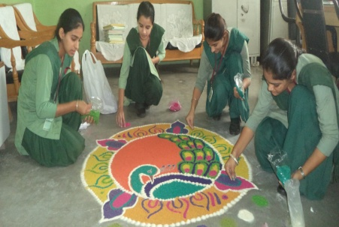
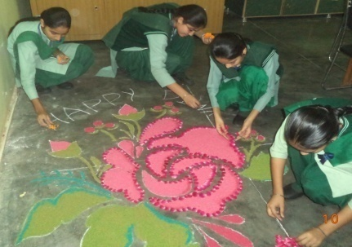
Colours play a vital role and the perfect blending of these is taught to the students in the Art and Craft department along with shading, sketching and portrait making.

EDUCATION EXCURSIONS
Regular educational excursions are among the highly important co-curricular activities. These excursions are conducted to acquaint the students with different flora and fauna folk arts and monuments and to expose them to local area, crafts, languages, landscape and industries. The students are assigned projects connected with these. The idea is to supplement their classroom studies and provide them first-hand knowledge of the world around them. Apart from these, adventure camps are also organized in order to inculcate in the students respect for discipline, self-dependence, leader ship qualities, love for adventure and self-confidence.

SPORTS
The school years are a time of extraordinary growth-physically intellectually, emotionally and socially. It is inevitable that a dynamic, energetic child should have a great desire to be exuberantly active. Therefore, the school provides facilities for all possible games and sports like Cricket, Basketball, Badminton, Football, Hockey, Volleyball and Kho-Kho and indoor games i.e. Chess, Carrom, Table tennis, Judo and Skating etc. Every student is required to participate in at least one sport involving physical exertion to keep the body in shape.

Likewise every student is required to participate in at least one stage activity i.e. the students can participate in inter House and Inter School sports and Cultural activities to get maximum exposure of the outer world.

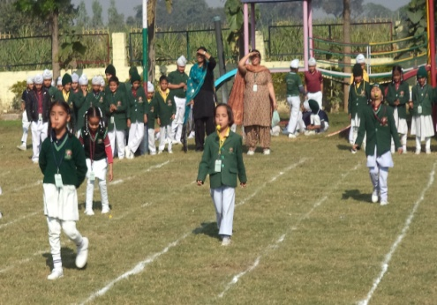
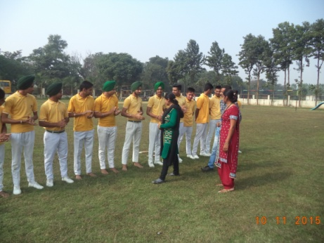
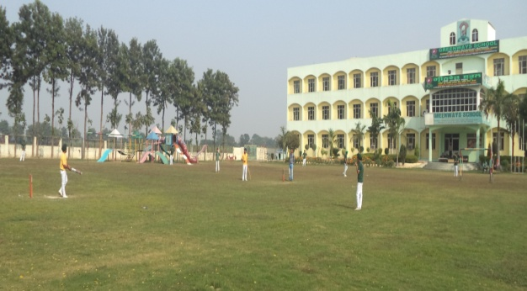

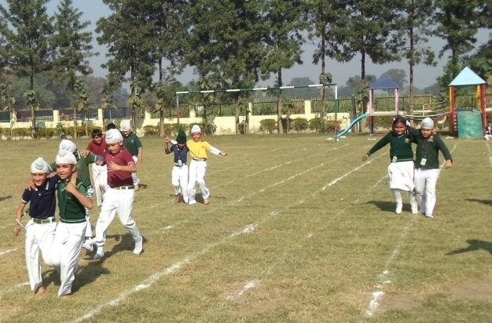
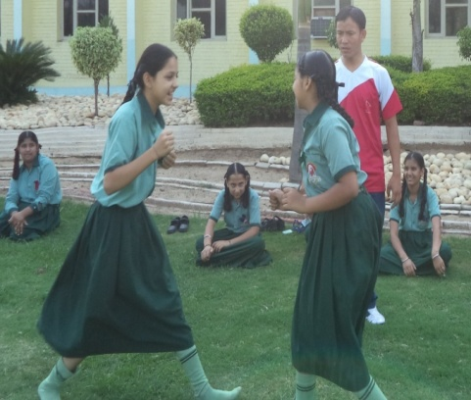
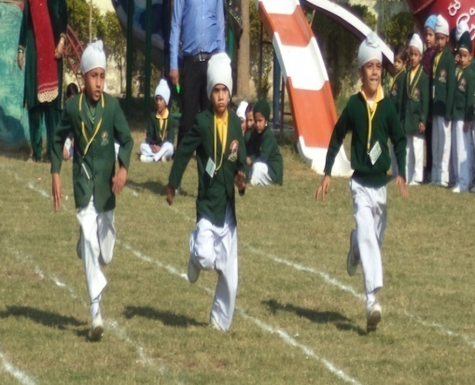

PREFECT SYSTEM
The prefect system is a unique feature of GWS(Greenways School). The students attaining first and second position in academics are honoured with prefect badges. The prefects assist the teachers in maintaining discipline in the class. If the child is not able to retain his/her position in the consecutive examinations, the badge is given to the child who attains the position befitted for the concerned prefect badge.

PARENT TEACHER INTERACTION
A child’s study progress is a matter of joy to the parents and to the teacher as well. Our school, realizing the importance of both, has set up the PTI sessions for the overall grooming/development of a child. Periodically on a stipulated date and time the parents and teachers meet to discuss the progress made by the child and how by the co-operation of both the child can excel in every field and present himself confidently as a responsible citizen.
This is a short as well as long term benefit to the child as this interaction is a fine platform where the problems or achievements of the child can be talked over freely so that the best possible way can be rooted out to channelize a child’s interest in a positive direction to obtain the desired and fruitful result. The endeavour of the school does not go in vain when the parents slice off some time from their otherwise busy schedule for this equally essential interaction devised by the school.

BIRTHDAY CELEBRATION AT SCHOOL
Bringing toffees to the school ever for celebrating birthdays is not encouraged, the following guidelines have been issued regarding the celebration of student’s birthday.
- Students, celebrating his/her birthday are allowed to come in colourful birthday dress.
- Sweets can be served instead of toffees.

VALUABLES AND CASH
Parents are requested not to give valuable items like wrist watch, ornaments, jewellery, cell phones, camera, i-pod and cash to their children. This will create a sense of inequality among the pupils and also nurture a bad habit of spending heavily. If any such valuable thing is lost in the school, school will never take any responsibility.

SESSION AND HOLIDAYS
The session of Greenways is April to March. The school has the following Breaks during the session:-
- SUMMER BREAK
- DIWALI BREAK
- WINTER BREAK
The list of the other holidays to be observed by the school has been given separately time to time in the session.

SCHOOL UNIFORM
The school uniform is a discipline in itself and should be adhered to by all the students. The set pattern and colour should be correctly followed. All the students are expected to wear the school uniform as specified. Parents are expected to ensure that their wards are in proper uniform.
SUMMER UNIFORM
BOYS:
- TURBAN- Light green/compulsory from class IX onwards.
- Under Turban-Dark Green
- Patka-Light Green
- Shirt-Light Green half sleeves.
- Shorts-Dark green
- Trousers-Dark Green class VI onwards.
- School Tie
- School Belt
- Socks Light Green with Stripes.
- Plain Shoes—Black leather with Laces.

GIRLS:-
- Suit-Light Green Shirt, Dark Green Salwar with Dupatta Compulsory form class IX onwards.
- Shirts-Dark Green half Sleeves.
- Skirt-Dark Green
- School Tie
- School Belt
- Socks light green with stripes
- Plain Shoes—Black leather with one strap and Buckle
- Ribbon Black compulsory for all.
WINTERS UNIFORM
BOYS:
- TURBAN- Dark Green—compulsory from class IX onwards.
- Under Turban—Light Green
- Patka—Dark Green
- School Cap—Dark Green
- Shirt-Light Green full sleeves.
- Trousers-Dark Green class VI onwards.
- School Tie
- School Belt
- Socks Dark Green with Light Green Stripes.
- Plain Shoes—Black leather with Laces.
- Pullover—Dark Green full Sleeves/Half Sleeves V shaped necked line.
- Blazer—Double Breast Dark Green with School Logo.

GIRLS:-
- Suit-Light Green Shirt, Dark Green Salwar with Dupatta Compulsory form class IX onwards.
- Shirts-Dark Green fill Sleeves.
- Skirt-Dark Green class IV to VII with Slacs
- School Tie
- School Belt
- Socks—Dark Green with light Green stripes
- Plain Shoes—Black leather with one strap and Buckle
- Ribbon—Black compulsory for all.
- School Cap—Dark Green
- Pullover—Dark Green full sleeves/Half sleeves v shaped neck line
- Blazer—Double Breast Dark Green with School Logo.
WEDNESDAY AND SATURDAY UNIFORM:-

SCHOOL TIMMINGS
Summer 8:00 am to 2:00 pm
Winter 8:30 am to 2:30 pm
WORDS TO PARENTS
As Greenways is stepping into new academic session and no doubt it is a proud moment for all of us, we have pledged to do our best for the harmony of the ‘Three Hs’—Hand, Head and Heart. The first ‘H’ i.e. Hand—signifies Physical Excellence the second ‘H’ i.e. Head—represents Academic or Scholastics Excellence and third ‘H’ i.e. Heart—symbolizes Human Excellence. Since learning is a treasure and it follows its owners everywhere, we are committed to create a large island of knowledge for our scholars.

GWS will certainly rise up to your expectations but only when the people of the area and the parents are with us. If you notice any discrepancy during the discharge of duty by any GWS member, the same may kindly be brought to the notice of the Principal of the school. The management and the staff of GWS is committed to quality rather than quantity.
ADMISSION:
The School is already affiliated upto 12th standard to CBSE New Delhi
- Registration: Any student wishes to seek admission to the school must get his/her name registered at school office. Registration fee is Rs. 500(not refundable).
- Eligibility:- A child must be minimum 3 years old on 1st April of the year if he /she seeks admission to nursery. The birth certificate of the child from the legal authorities must be submitted at the time of the admission.
- Students coming from other schools, please submit
- Attested photocopy of Birth Certificate of the child
- Transfer Certificate from Previous School
- Last Report Card from Previous School
- Proof of Residence: Ration Card, Passport, Election Card, Driving License
- One-one passport size photograph of parents
- Three passport size photographs of the child.

- The School admits students for the 10+1 classes in Non Medical, Medical, Arts and Commerce streams as per CBSE norms.
Subject offered: English, Physics, Chemistry, Maths, Biology, Physical Education, Punjabi, Accountancy, Business Studies, Economics, Political Science and History.

- Admission withdrawals: One month notice has to be given in writing to the principal or else the caution money/security deposited will be forfeited. Transfer Certificate/Migration/School leaving certificate or even the provisional will be issued after all school dues have been cleared. The school will issue the same after 15 days of receiving the application. The same will be given at a payment of Rs. 50/-

LEAVE OF ABSENCE:

Absence from school hamper’s studies and other educational development. Children are advised not to miss classes. Parents are requested to ask for leave only in unavoidable circumstances. Application for leave must invariably be sent by the parents/guardians before their wards are to avail leave. In the absence of application, a fine of Rs. 5/- will be charged. If the student remains absent for more than 10 days without application his/her name is liable to struck off the roles. Re admission may however be sought with the principal’s permission.
Parents are also requested not to ask for taking away the child between school hours unless it is an emergency.

No child will ever be sent with or handed over to any person except the parents/guardian/person authorized in writing by the parents/guardians with the ID proof of Parents as well as the person who will take the child from school.

HEALTH CARE:
Routine medical check up of students will be a regular feature. School are organized every third month which include free eye and dental checkup. Students all round health records are maintained and checked by the team of qualified doctors.

GENERAL GUIDELINES FOR PARENTS/GUARDIANS

- COMMUNICATION:
Any communication made by you should be addressed to the Principal through the class teacher and should always be quoted with the Name Roll no, Class and section of your ward. You are requested to inform the school if there is any change in your address or mob numbers.
- UNIFORM:
Your ward should come to school in proper uniform on all working days and for all the school functions. Students who are not in proper uniform will not be allowed to attend the school and will be sent back immediately and you will have to pay Rs. 100/- for transporting your ward back to your home. In case of genuine problem an application stating the reason should be sent with the child.
- Discipline:
- You are requested to co-operate with the school in its attempt to help your ward’s progress by paying attention to his/her regularity, punctuality and discipline.
- Parents are requested not to enter the classrooms to see their children or teacher during school hours.
- In case of any legitimate complaint or if you feel your ward is not making the desired progress you should meet the principal/Head Mistress at the earliest or write to him/her personally.
- Parents’ attention is drawn to the fact that the criticism of the teacher of the school in the presence of a child should be scrupulously avoided because it may develop in the students the tendency to lose respect towards their teachers.
- Restrict daily pocket money to the minimum Excessive spending should be discouraged.
- Absence from the school
- Students suffering from infectious diseases such as Conjunctivitis, Dermatitis, Scabies etc should not be sent to the school until they fully have recoverd.
- Children when sick should not be sent to the school.
- Students suffering from chronic diseases like Asthama, Epilepsy, Rheumatics, Heart diseases etc are advised to be under medical supervision of a specialist, history of their illness must be informed separately in writing, along with the names of the medicines prescribed by the doctor.
- A word to the parents:
- All students are expected to speak in English while in school and we request the parents to do so at home as well.
- Parents are advised to be conscious about the fact that the school is actually a supplement to the home and not its substitute. It is very improtatnt that parents/guardians extend unstinted co-operation to the school in all matters concerning their wards.
- Parents must ensure that their wards do not carry any electronic articles such as mobile phone camera, pager, walkman, music player etc to the school. Possession of such items by students in the school is treated as an offence and all such items will immediately confiscate.
- Visiting Hours Meeting With Principal
In case the parents wish to meet the Principal on other than the says specified for Parents Teacher Meeting they should seek prior appointment form the receptionist. The Visiting hours are
Principal : 12.00 noon to 1:00 pm on Wednesday and Saturday
Teachers : after 12.00 noon in their free periods only

EXCURSIONS AND INTERNATIONAL TOURS AS A PART OF THE STUDENTS EDUCATION
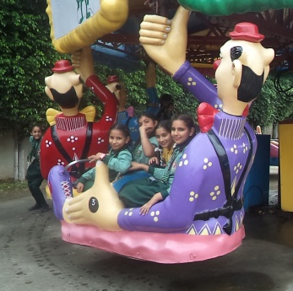
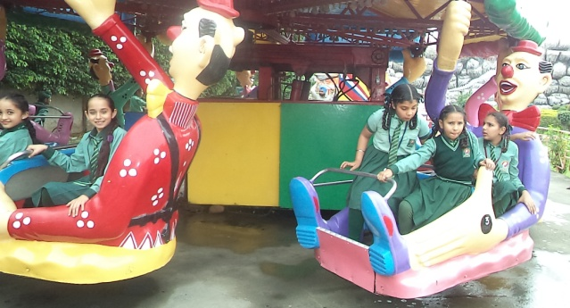
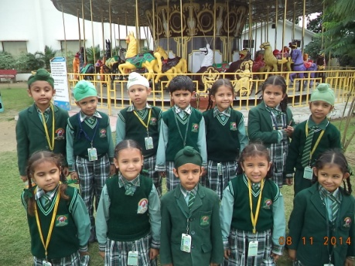

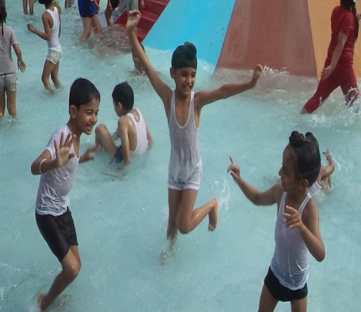
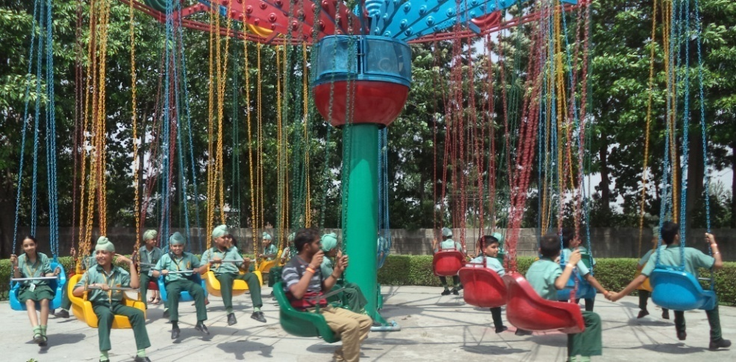

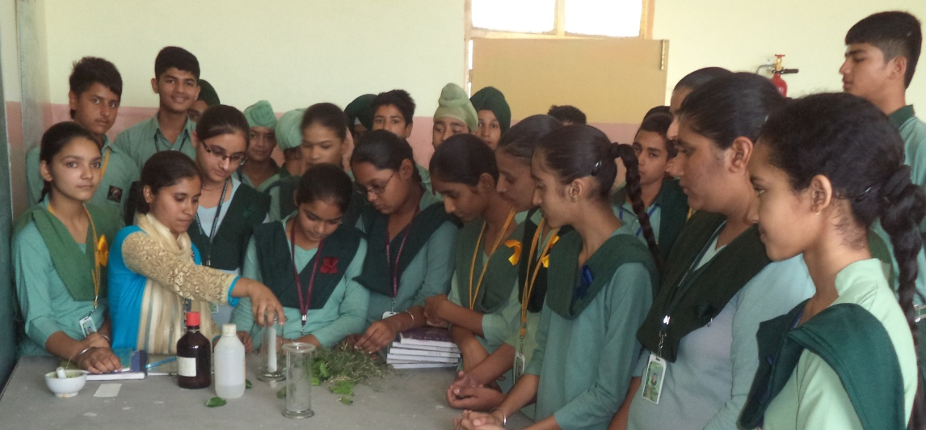

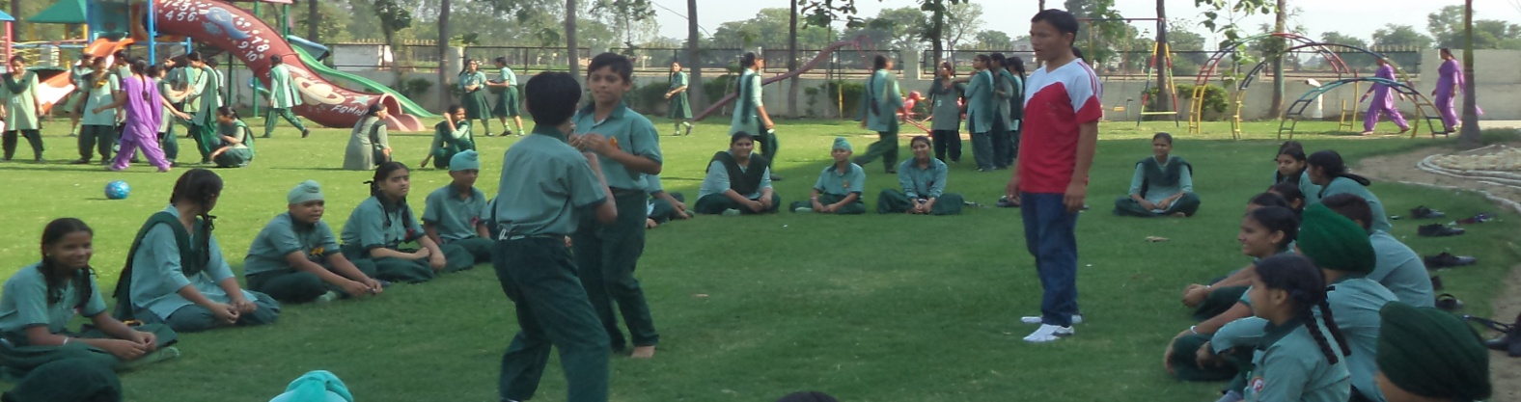
SPORTS IN SCHOOL

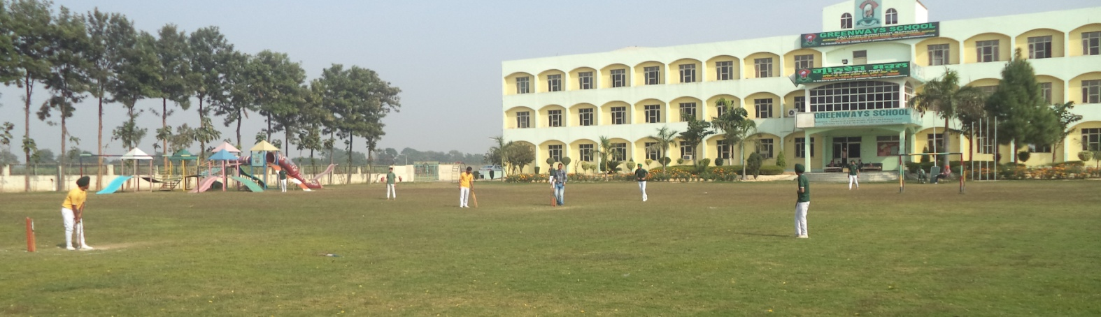

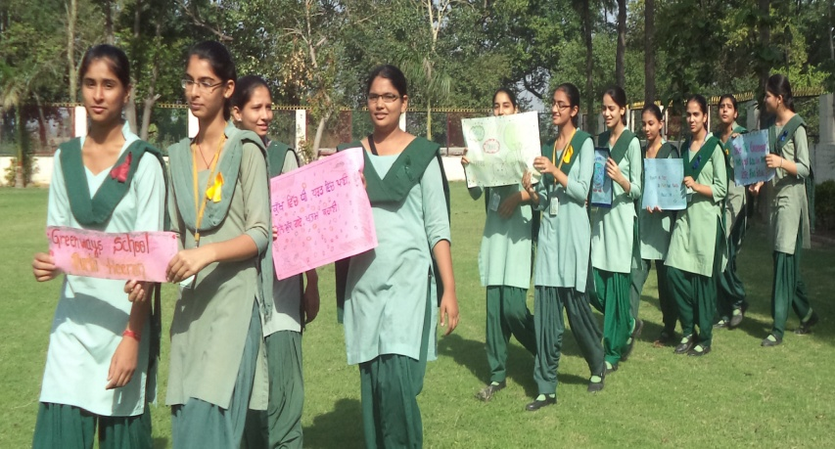
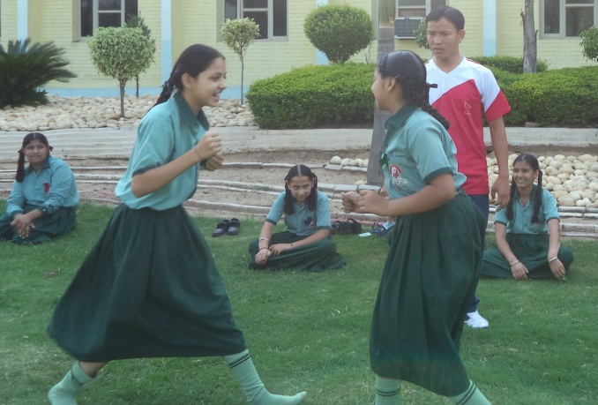

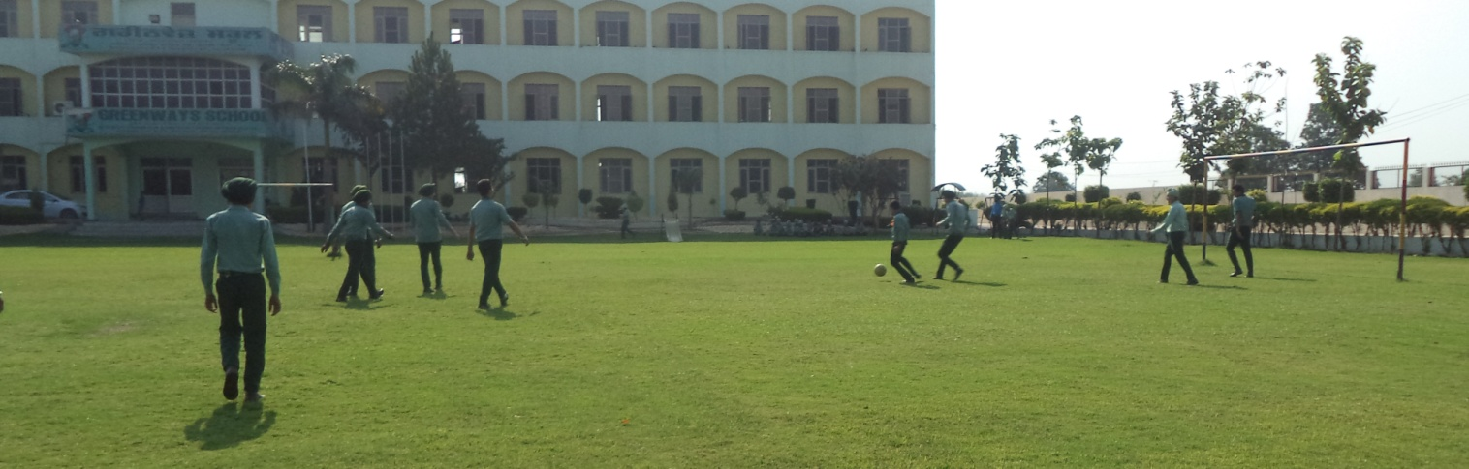

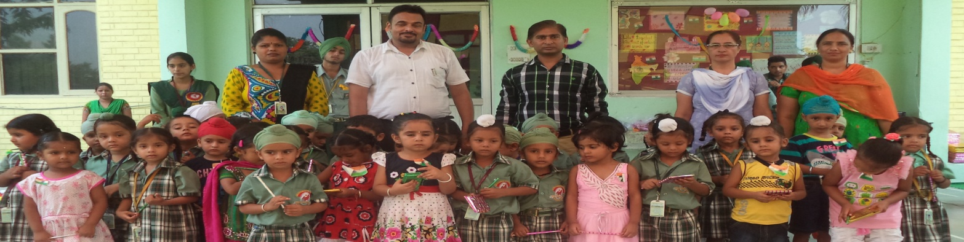
PRIZE DISTRIBUTION

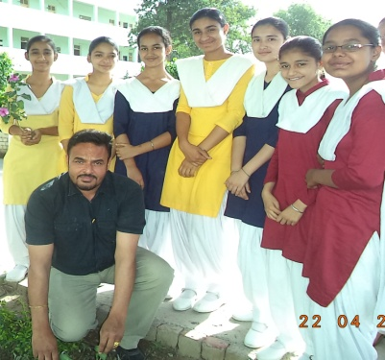
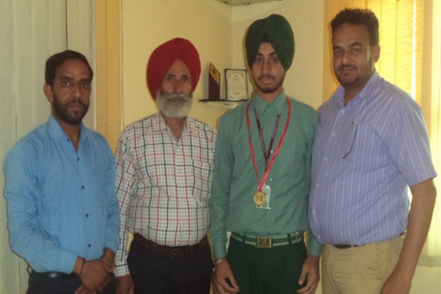
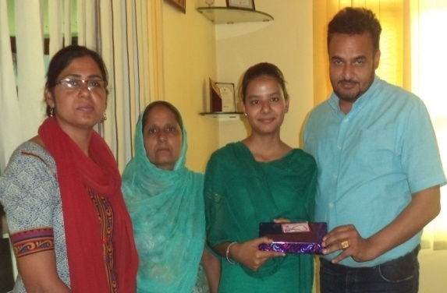

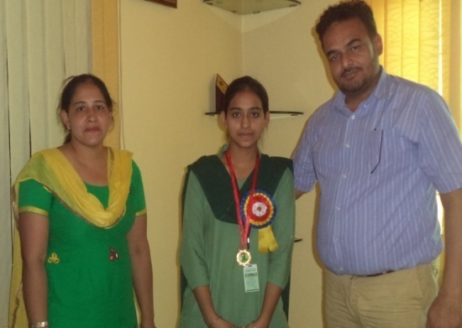
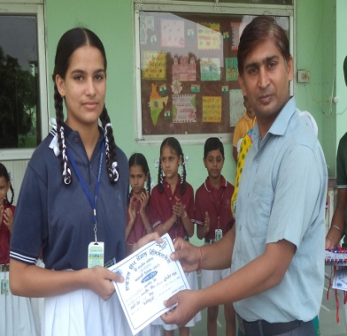
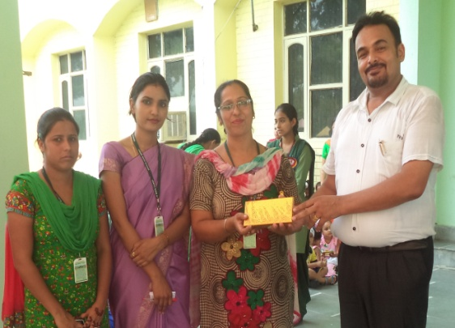

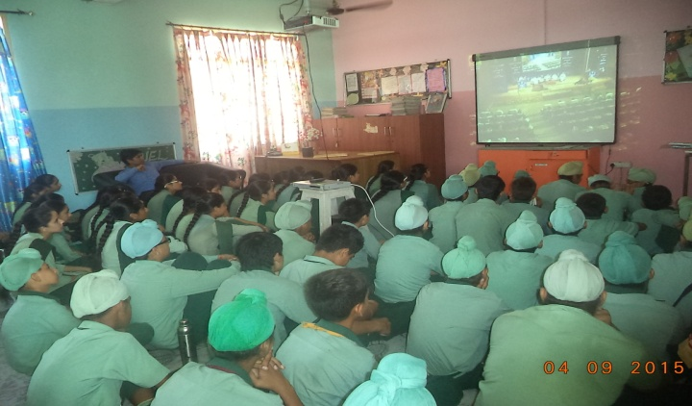

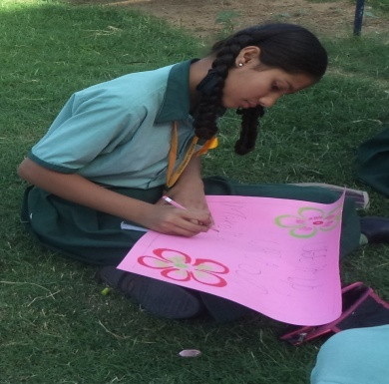
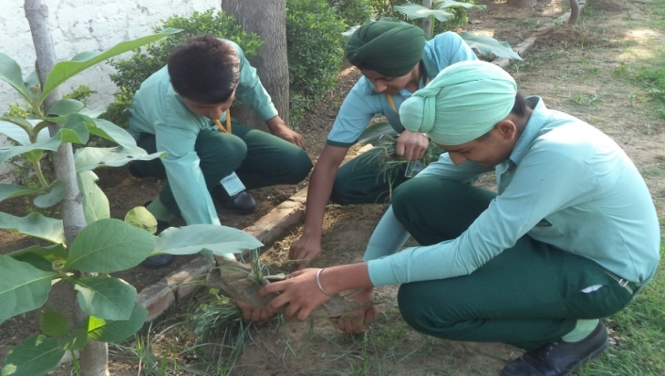
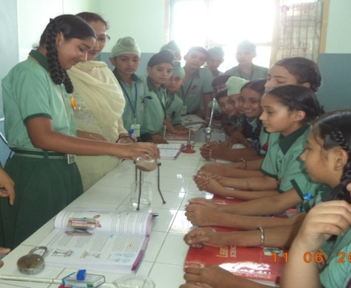
ACTIVITIES CONDUCT IN SCHOOL

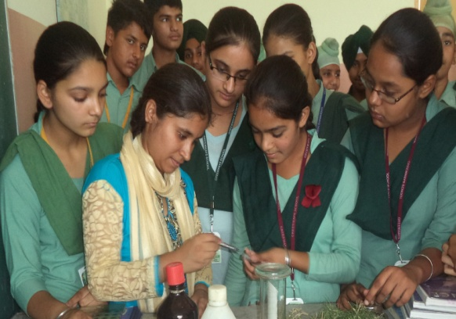
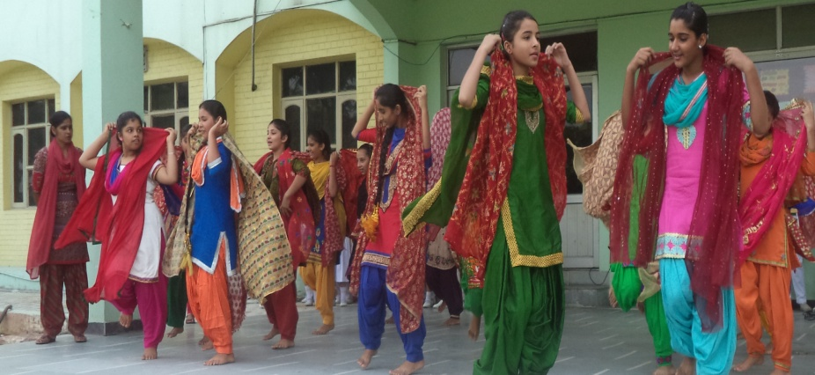
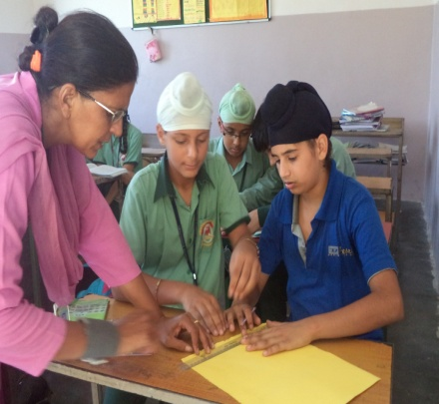
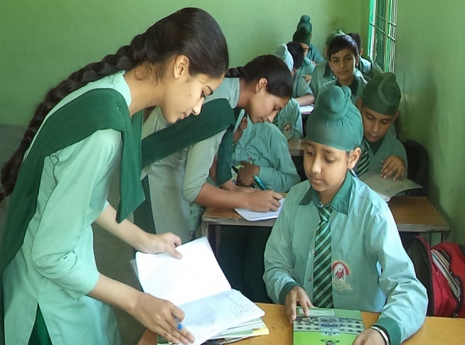
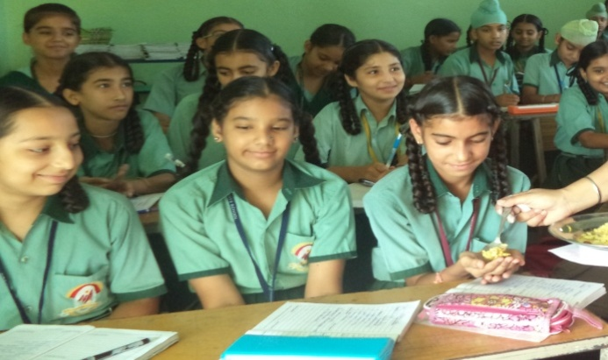
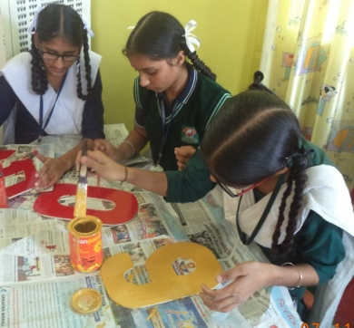
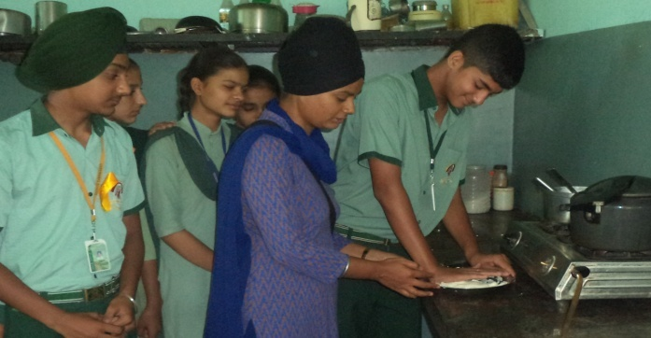
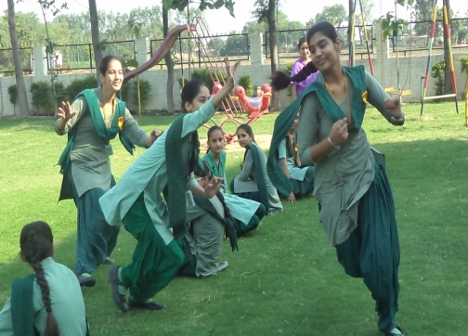

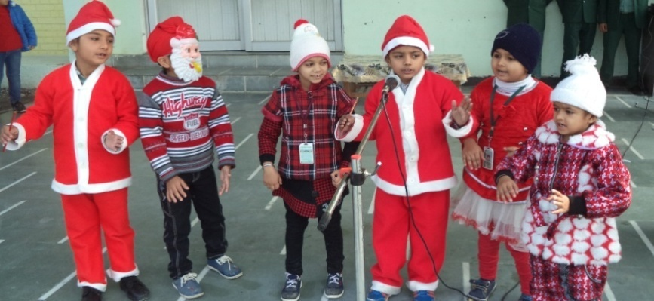
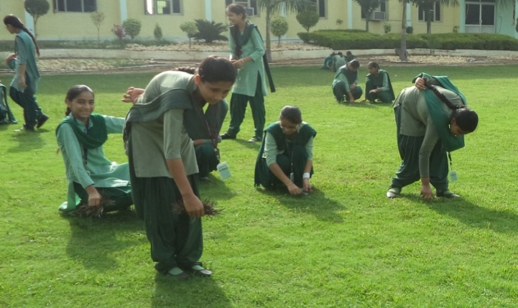

JUNIOR SECTION ACTIVITIES CONDUCT IN SCHOOL

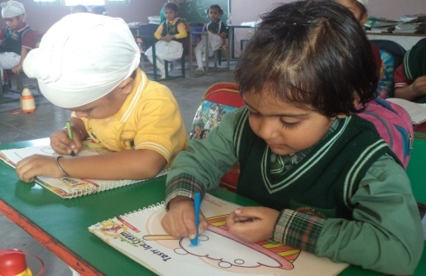
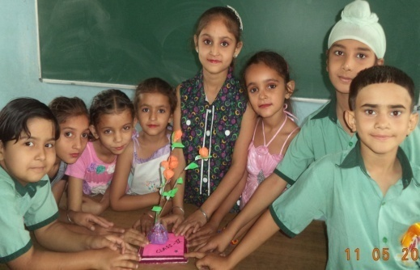
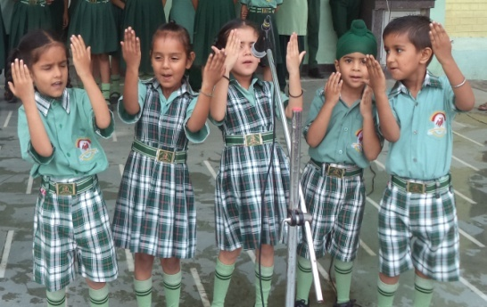

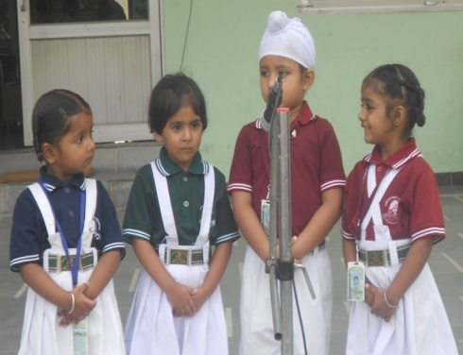
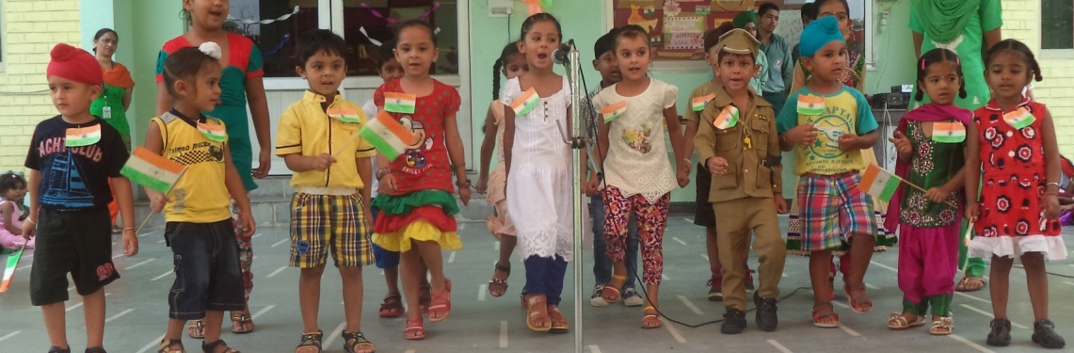

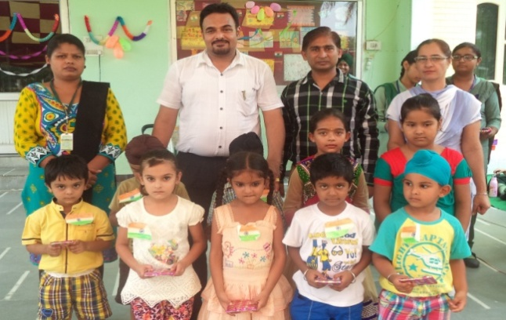
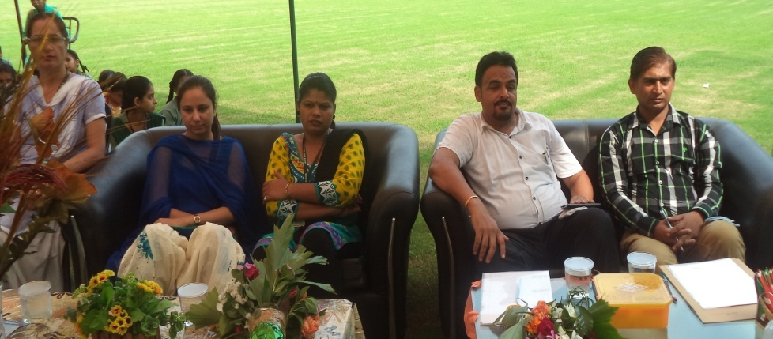

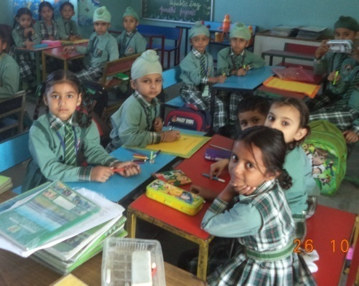
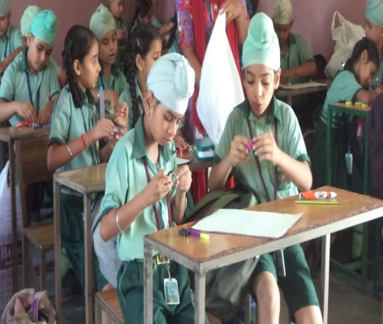
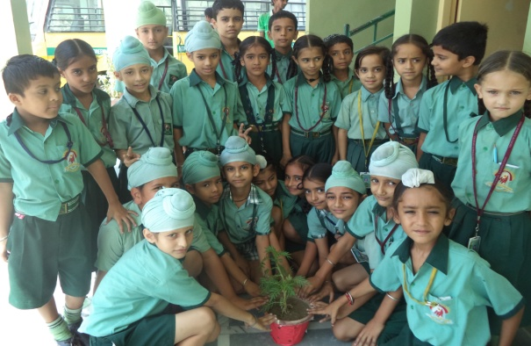

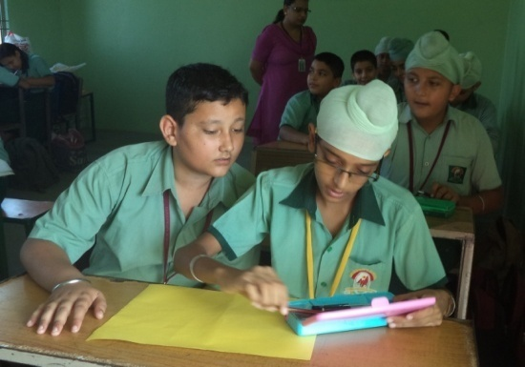
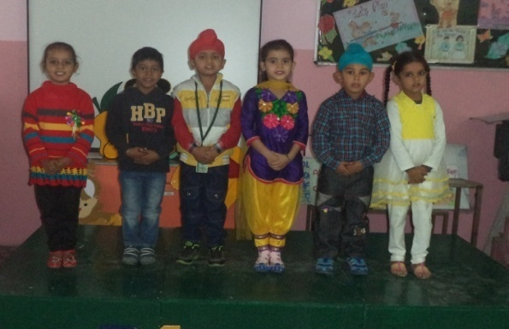
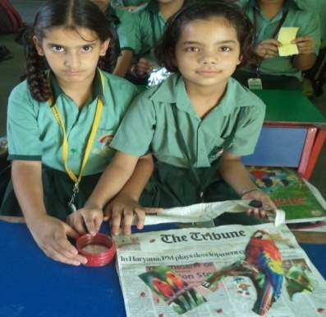

CELEBRATION OF ANNUAL FUNCTION

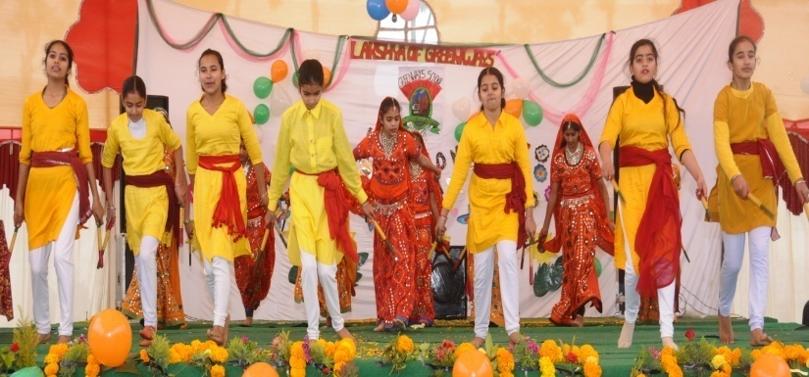
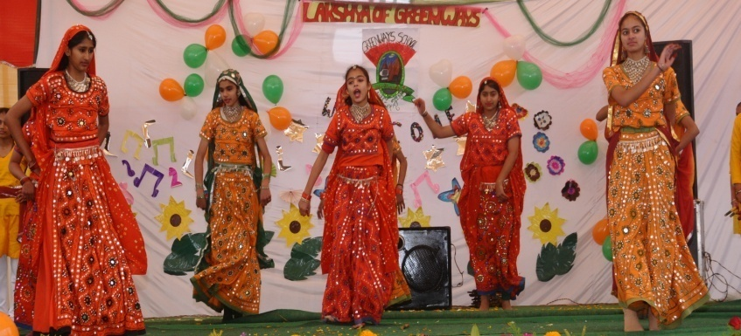
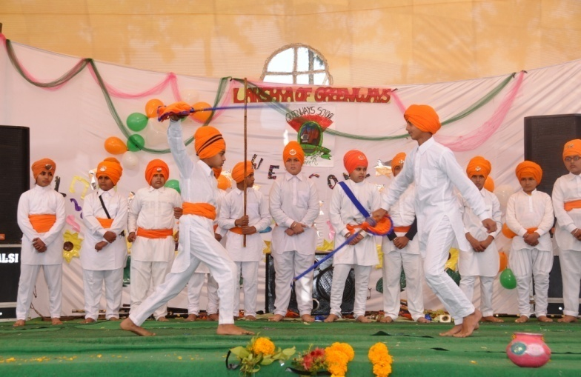
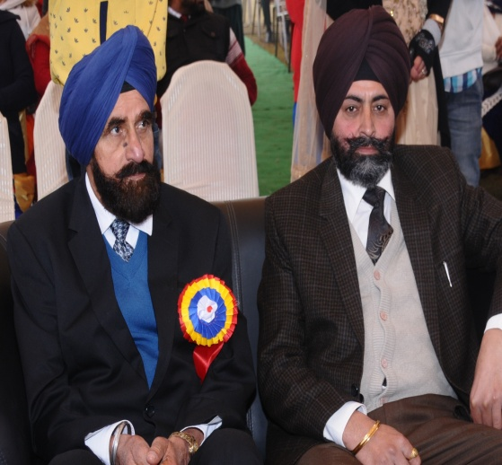
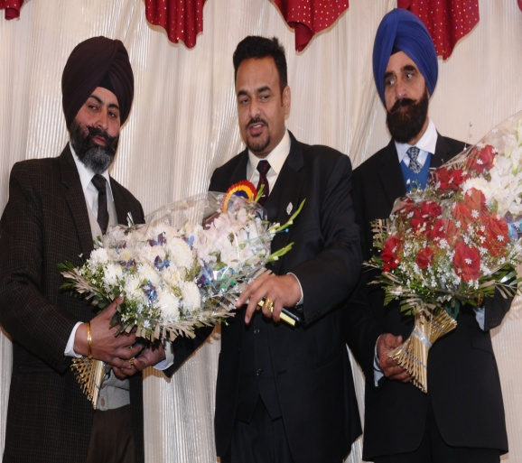
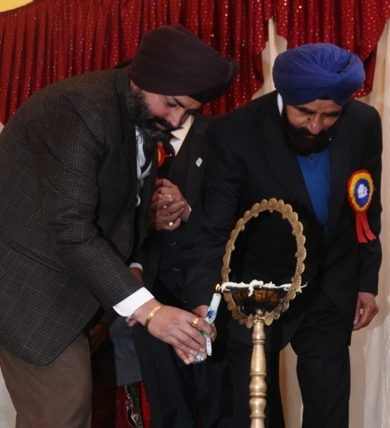
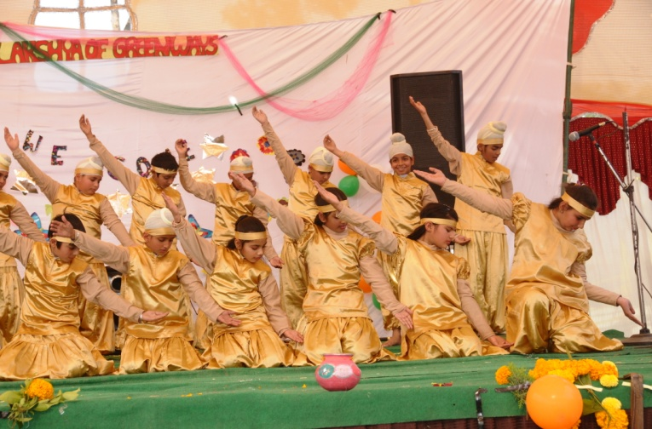

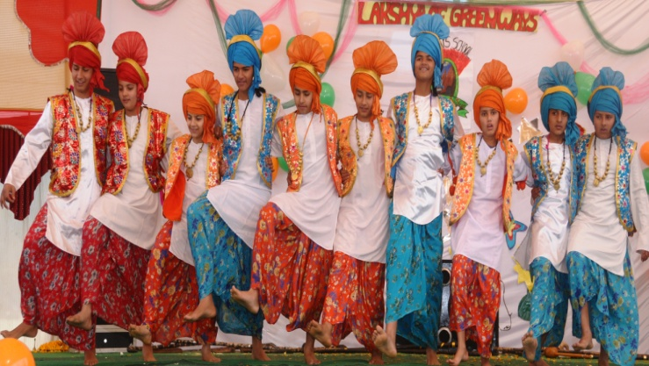

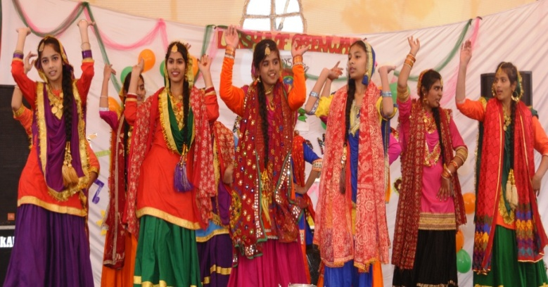

OTHER ACTIVITIES CONDUCTED IN SCHOOL

